**Account Package**

This package contains the use cases that pertain to a User’s ability to create and interact with an account in the StayConnected system.

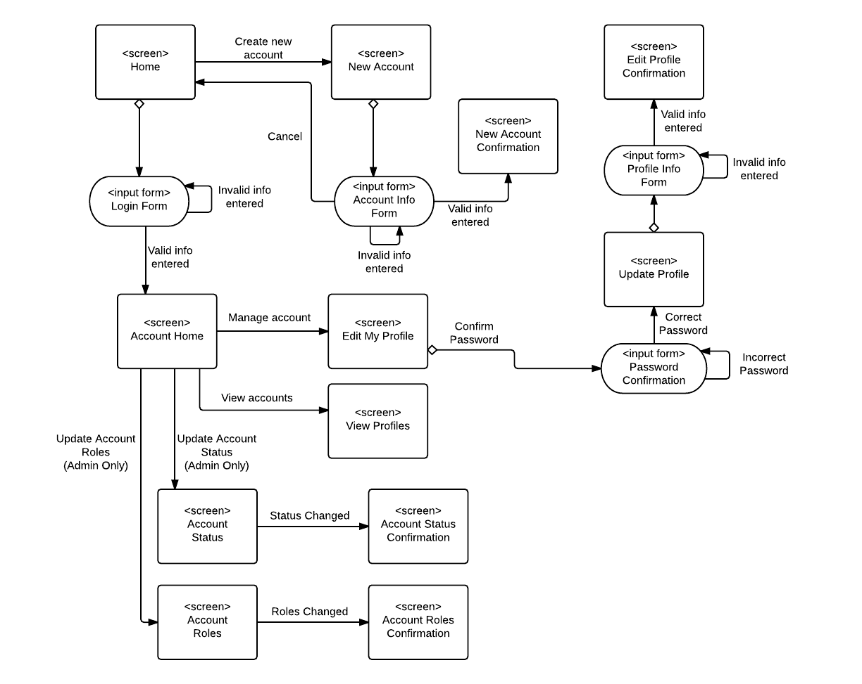

**Job Package**

This package contains the use cases that pertain to a User’s ability to create and interact with job listings in the StayConnected system.

